Game Design Missive

Touhou Sunset Kaleidoscope

**東方－夕暮れの万華鏡**

Touhou - Yūgure no mangekyō

Authored by Ámilie Minerva van Heusden & Daniel Trandafir - Version 1.1

**Genre:** Bullet Hell / Shoot ‘em up

**Platform:** PC

**Target Audience:** People interested in the Bullet Hell genre and/or the Touhou Game Series

**Quantic Gamer Types:** Acrobats, Bards

**Premise[1]:** Gensokyo is a land filled with many mystical beings, from Fairies to the Gods themselves. Yet among their countless throngs stands one, her presence felt by all, but seen by none: The Patron of Light. Like all other Gods in Gensokyo, she derived her powers from the faith given to her by the humans. However, the humans’ understanding of the world has changed and they no longer believe in The Patron of Light, and as such, light is slowly fading away from the world. Seeing this as a particularly severe incident, the Maiden of the Hakurei Shrine goes out to investigate what is happening.

**Setting and World:** The game is set in a world called Gensokyo, a place for the forgotten of the world. A sealed off region of the real world, where those who wouldn’t be missed end up, whether that be your every day loner or forgotten deities. The series is well-known for its huge cast of characters, well-developed storylines, difficult gameplay and related materials such as music CDs, fan-made comics and animated music videos.

**Gameplay Overview:** The game itself is a Touhou fanmade game, meaning it will follow the formula of the latest mainline games made by *Team Shanghai Alice*: a challenging vertical-scroller *danmaku* (bullet hell) with a focus on precision dodging and pattern recognition.

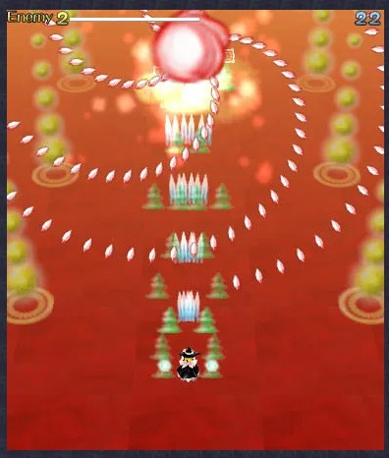

**Visual Style:** Characters draw from Japanese folklore, each boss having a distinct visual style, while the color palette tends to be bright and colorful, which helps distinguish bullet types and patterns; the bullets themselves often resemble flowers or spirals, creating patterns that are both threatening and beautiful.

**Key Features:**

* **Spellcard System:** Bosses attack with unique bullet formations, which gives each boss personality and thematic coherence.
* **Micro-Hitbox:** The player’s hitbox is significantly smaller than the sprite, enabling tight dodges through dense barrages.
* **Resource Management:** Players juggle lives, bombs, and power-ups, with a scoring system that rewards risk-taking
* **Music & Flow:** Fast-paced, melodic soundtracks are tightly tied to gameplay, reinforcing mood and pacing.

**Competitive Analysis:** Unlike other bullet hells**,** Touhou distinguishes itself through artistic bullet design, character-driven spellcards, and a strong fan-driven culture.

**Development Team:** The team consists of two people, Ámilie Minerva van Heusden & Daniel Trandafir. Responsibilities are shared, and both have experience in game development.

**Project Status:** Currently in pre-production, the foundations are being laid in the Unity Game Engine, with prototypes and art creation underway.

For inquiries contact:

Ámilie Minerva van Heusden, Developer

[534619@student.fontys.nl](mailto:534619@student.fontys.nl)

Daniel Trandafir, Developer

[546072@student.fontys.nl](mailto:546072@student.fontys.nl)

1. The Premise is fully original, though it is inspired by the game series in general.